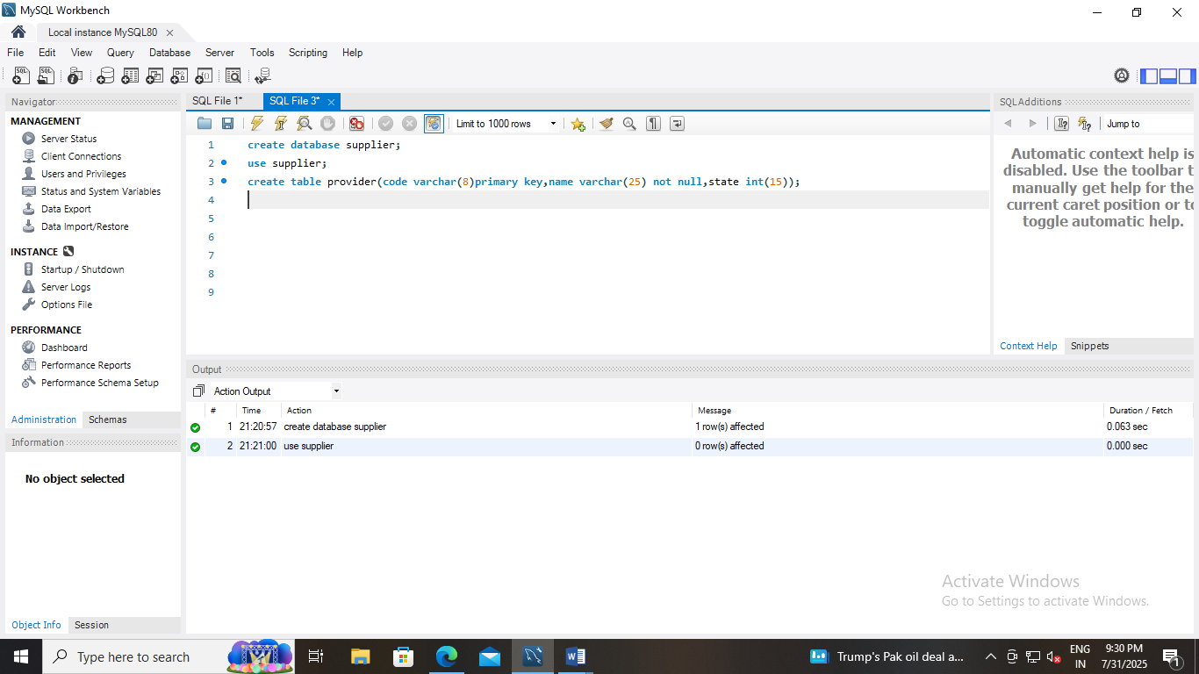
create database supplier;
use supplier;
create table provider(code varchar(8)primary key,name varchar(25) not null,state int(15));
insert into provider(code,name,state) values ('hkg','sri enterprises',90909308);
insert into provider(code,name,state) values ('kfe',' monoj enterprises',909587408);
insert into provider(code,name,state) values ('higw','skollington suppliers','78945618');
insert into provider(code,name,state) values ('mat','anand suppliers','98648753');
select* from provider;
